**Mini**  **Project**

Course Name : Electrical Circuits Course Code : CSE209 LAB

Section No : 04 Project name : Voltage Divider and Selector Circuit

**Submitted to**

Course instructor : Rashedul Amin Tuhin

Senior lecturer

Computer science and engineering

**Submitted by**

Name: Apurba Roy Ajay

Student’s ID : 2018-3-60-063

Department : Computer science and engineering

**Date of report submission : /09/2020**

Problem Statement:

Here a 10V DC supply is available.We need to use 10V, 5V, and 3V as supply voltage of a low current electrical circuit. Design a voltage divider circuit so that the desired voltage can be selected at the output.

Design:

The design of the DC circuit is given below:

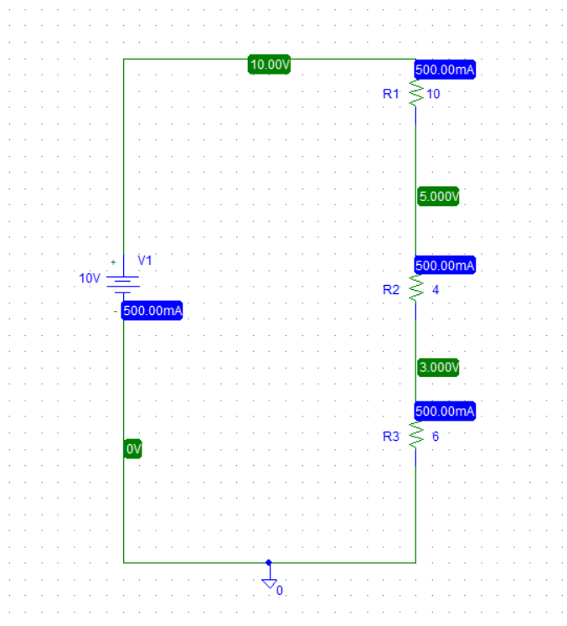

We draw this circuit by VDC with three Resistor and a voltage source and a ground.The value of three resistors are 10kΩ, 4kΩ and 6kΩ and the voltage source value is 10V.All the resistor are in parallel.

Experimental Results:

At first , I want to get a result like 10V ,5V and 3V as a supply from this circuit .Then in pspice I draw a circuit and given the value of resister.After the simulating I got these three voltages as a supply from this circuit.If we consider three node called A,B,C at node A we get 10 voltage then at node B we get 5 voltage and then at node C we get 3 Voltage as a supply.This was our expected result from this circuit.

Conclusion and Discussion:

We connect this circuit using Pspice software.I think if we could do this same experiment in the lab, the measure value would change a little bit and most importantly we could learn how to connect the circuit for real life. I cant able to use switches on this circuit otherwise the project would be the as same as instructed in our project sheets .